ANATOMY OF A BOMBING MISSION
Annette Tison 2017

The 392nd BG had one purpose-to place bombs on the target. This article describes the process by which that happened. Much of the information on mission preparation comes from Roger Freeman's book, The Mighty Eighth War Manual. In it, he noted that "For every combatant in 8th Air Force there were 20 personnel in a supporting ground role."
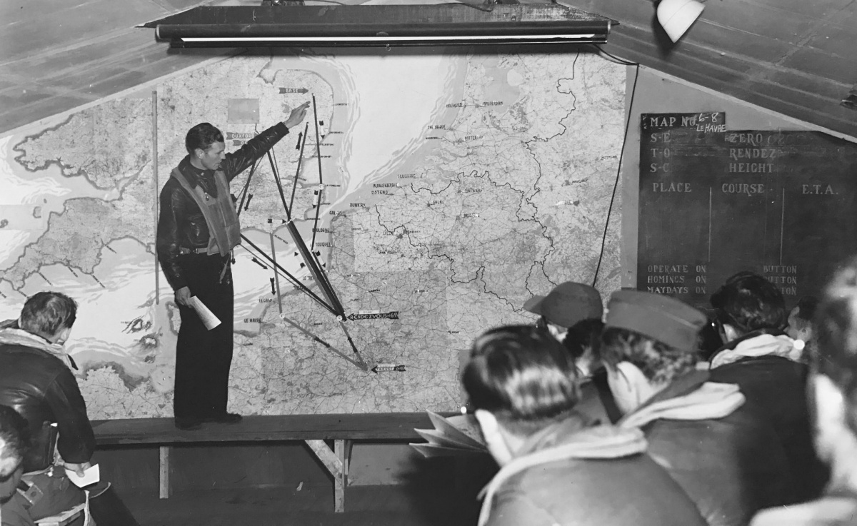

At Eighth Air Force Headquarters
In the early days especially, the main factor affecting air operations was weather. Briefings were held three times daily at 8AF headquarters to give senior operations officers a forecast for prospective target areas and bomber bases in England. If the forecast was reasonable, the Operations staff selected suitable targets from a prioritized list.
Weather also affected the size of an operation. Clear skies might lead to a concentrated attack on one of the most important targets in the priority list. With cloudy conditions, the bombers might be split between several targets to increase their chances of success. If only part of enemy territory had a suitable weather forecast, target selection might focus on that area.
After weighing all options and up-to-date weather and operational data, the 8th's Chief of Operations made a decision about targets, the force required to destroy them, and a coordinated plan for the participating divisions. This information and supporting details became the formal Field Order (FO). However, to give participating units enough time to prepare aircraft and brief personnel, many operational directives reached units as an advance to the FO. Many FOs were cancelled before they evolved into a mission.

At 2nd Air Division Headquarters
After 2AD was notified of an impending mission, it alerted its Combat Wings who then informed their Groups. When 2AD got the target and ordnance requirements, specialists studied target indentifications, established Mean Points of Impact (MPI, the intended center for all dropped bombs), prescribed the type and quantity of bombs to be used, assessed the force of aircraft needed, plotted routes and times and specified altitudes. 2AD also coordinated appropriate support by 8AF Fighter Command.
These details were sent to Combat Wing headquarters as they became available. Combat Wings and Groups could start their mission preparations after learning only the intended target, the order of Combat Wings, the number of squadrons in each, and tentative routes and times.

At 14th Combat Wing Headquarters
The 14th CW directed the 44th, 392nd, and 492nd BGs. It dealt primarily with operational matters; its major function was to create a coordinated plan for its Groups during all stages of a combat mission and to act as the controlling agency throughout. A flurry of annexes to the FO flowed back and forth along the chain of command, advising of changes and adding new information.

At the Bomb Groups
The individual Groups were told of an impending mission via a telephone call on the secret "scrambler" line in Group Operations' Message Center. The Watch Officer immediately had his duty clerk notify all affected base services that an alert message had been received. They included the CO, Air Executive, S-3 Group Operations Officer, S-2 Intelligence Section, Group Navigator and Bombardier, Weather Office, Flying Control, ordnance and armament sections, engineering office, signals and photographic units, mess hall, transportation (motor pool) and the Charge of Quarters (CQ, or duty sergeant) on each squadron living site.
The ripples from the alert order kept spreading. The duty officer informed the guard room, told the base telephone exchange to restrict calls and asked that Military Police be posted at the doors of Operations and the War Room (the main office of the Intelligence Section). CQs raised a red flag on the living sites, restricting personnel to the base. Squadron operations officers went to Group Ops to get advance FO information on how many a/c the group had to provide and bomb and fuel loads. Their first job was to update crew and aircraft status boards. Then, a list of available planes and crews was created and assignments made.
The initial alert gave the name of the target in code. In the War Room, the S-2 officer decoded the target and clerks pulled the appropriate folder. The S-2 officer plotted the MPI on target photos while S-2 clerks assembled maps, photos and all other target material needed to brief combat airmen. Ops personnel affixed a ribbon to the large map in the briefing room to show the route to and from the target and points of fighter escort.
The Group Navigator's office plotted courses, distances, and times for assembly. After weather data for temperature and wind speed expected on the route were obtained, air speed, ground speed and drift on each leg of the route were calculated and checked against Division figures.
The Group Bombardier's office assessed target conditions and used wind, a/c speeds, drift and heading data to compute bombsight settings for the attack altitude. A schedule was established so the Group would be ready on time. Working backward, planners needed to allow at least an hour from the first take off for formation assembly (longer if the weather was poor); 10-15 minutes for marshalling and taxiing; 10-15 minutes for starting engines; 10 minutes for crews to board a/c; an hour before engine start for crews to inspect their a/c; an hour for main briefings; an hour for breakfast; and 30 minutes for crews to be awakened. Reveille for combat crews was therefore about five hours before take off time.

Bombs
Ordnance was informed as soon as the required bomb load was learned and the process of moving the bombs onto trailers at the bomb dump, transporting them to the hardstands, and loading them into the planes began. Other personnel brought belts of .50 caliber ammunition to the planes. The wooden boxes were placed throughout the ship for the gunners to set up when they arrived. The machine guns, removed from the planes after every mission for cleaning, were also brought back.
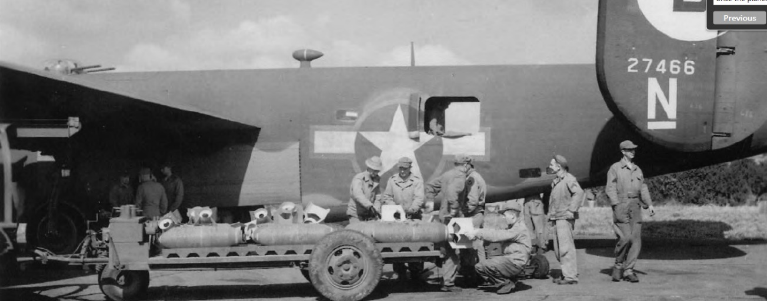

576th Sqdn armorer Tom Perry says, “At the far left of this photo is the bomb service truck’s I-beam, which had the rolling hand crank hoist for loading and unloading the heavier bombs. Using the winch took too much time, so we usually loaded the bombs by hand. The man at the back of the trailer is attaching the tail fin, which is secured by a ring collar screwed onto the threads on the bomb itself. The four men by the waist window are using grappling hooks on two rods to lift the bomb onto the dolly, a three-wheeled cart. Then, the bomb shackle is attached and the dolly moved under the bomb bay. We hoisted it up and hooked the shackle to the bomb rack. The last step was to attach the nose and tail fuzes. Usually a team worked on each side of the same bomb bay. There was a beehive of activity at the planes before the crews arrived!”
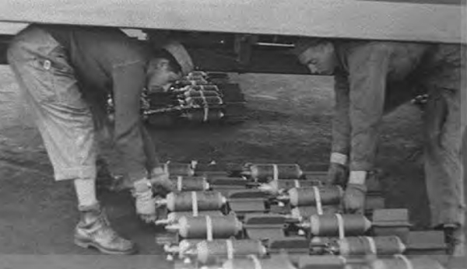

578th Sqdn personnel at work. At left, Cpls Gaetano (Guy) Spinelli and Ken O’Boyle prepare to hoist fragmentation bombs into a bomb bay for D-Day.
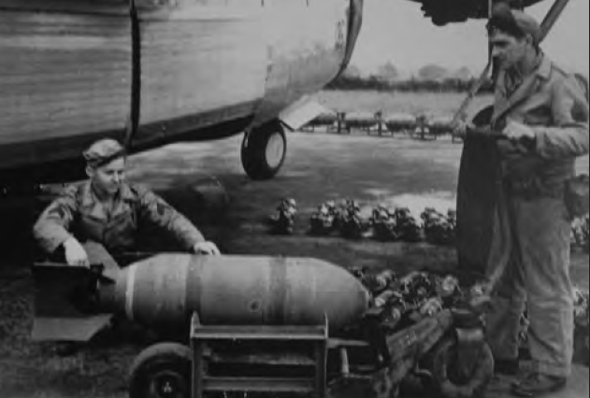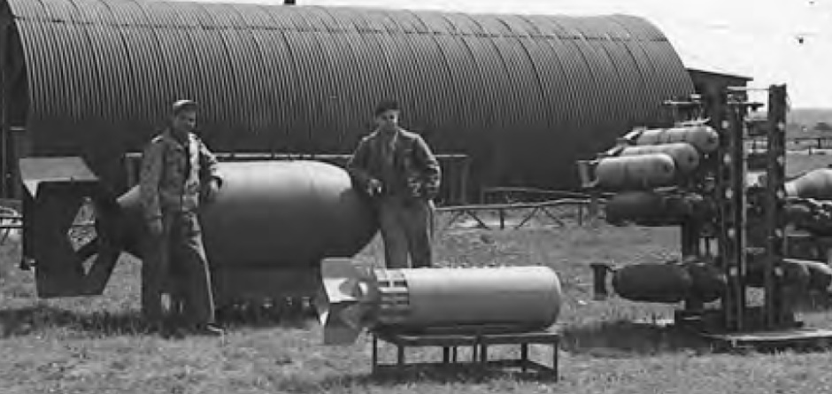

This display shows the variety and sizes of bombs dropped by the 392nd BG (and therefore unloaded, inspected, stacked and stored by the 1825th Ordnance Co.)
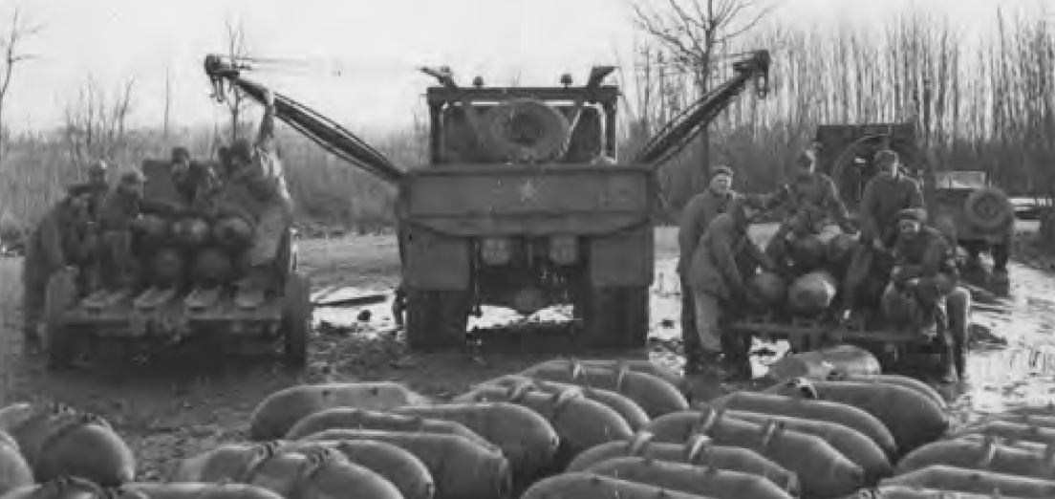

Men at work in the bomb dump on 2 Jan 1944.
The Field Order gave the number of ships each Group was to provide, the type and number of bombs per plane and the settings for the nose and tail fuses.
The Army Air Corps and the Navy used the same bombs but attached them to their planes differently. As a result, each bomb had three lugs: one near the front and tail for use in AAC planes and one in the center on the other side for use in Navy planes. (576th armorer Tom Perry said the Navy's lug "always got in the way" when loading bombs.) A metal clip called a shackle was clamped onto the two lugs; the shackle was then hooked onto the bomb rack.
When the bomb was released, the shackle disengaged simultaneously from both ends of the bomb. A bomb was "hung up" when one end did not completely separate from the shackle. An airman then had to step out on the narrow catwalk in the bomb bay (without a parachute, as he wouldn't fit if he wore one), often at bombing altitude, and kick the bomb loose.
8AF bombs ranged from 6 to 4,000 pounds and were of five types: General Purpose (High Explosive), Incendiary, Armor Piercing, Semi-Armor Piercing and Fragmentation. Different types and weights of bombs were often carried in the same B-24. For example, on 29 Apr 1944 the 392nd's planes were each loaded with five 1,000-pound GP bombs and three 100-pound Incendiaries.
The bombs had a fuze in both the nose and tail; as a precaution, these were inserted at the last minute. A cotter pin kept the firing pin locked in place, preventing detonation. This cotter pin was pulled out by an airman when the plane was on its way to the target.
Each fuze also had an internal wind-driven vane which had to rotate between 18 and 690 times (depending on the type of fuze) before the fuze was fully activated. As each bomb was loaded in the plane, a wire was attached to each fuze vane and then connected to the bomb rack. This arming wire kept the vane from spinning while the a/c flew to the target. As the bomb dropped, the arming wires pulled out, enabling the vanes to spin freely and completing the arming process.

Bullets
Station Ammunition Officer Charles Dye recalls, "When we first started operations in September 1943 the ammunition came to us in boxes already linked into belts. Later, as more Bomb Groups arrived and more ships flew, the ammunition came loose in wooden boxes as did the metal links. They had to be linked by hand with a machine that could link 10 rounds at a time. This was a time-consuming job. Later, we received an electric linking machine but still had to feed it by hand. Following the linking, the belt had to be checked for proper spacing to ensure that the gun wouldn't jam.
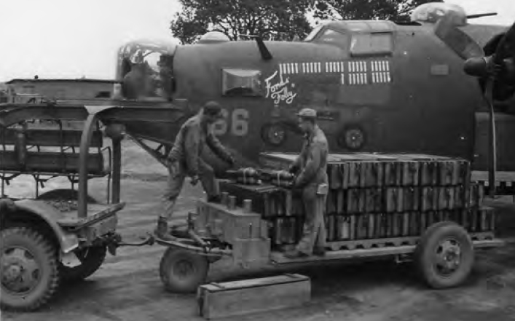

Loading 42-7466, Ford's Folly, with bombs and bullets for a mission on D-Day.
"Men in the ammunition section spent eight to twelve hours a day linking bullets. After the belts were inspected, they were turned over to squadron ordnance, which kept a large supply of belted ammo at their huts. 1825th personnel replenished the supply of belted ammo as necessary."
"Initially, the ammunition was linked 5-1, that is, 5 armor piercing and 1 tracer. Later when the incendiary round became available we linked them 2-2-1, meaning 2 armor piercing, 2 incendiary and 1 tracer.
"Many gunners 'smuggled' extra bullets onboard. There were a few instances when the a/c commander had to actually restrict this practice due to overload of the aircraft."

1825th Ordnance Supply & Maintenance Co.
1825th CO Jack Teufel says his main responsibility was the bomb dump at Honeypot Wood. Convoys carrying bombs showed up at all hours of the day and night. After unloading the trucks, 1825th personnel inspected each bomb for damage in shipment and then stacked them in rows, by type and size. It was a daunting task. For example, the 1825th history says that during July 1944 alone, 1,367 tons of bombs were unloaded from convoys while 840 tons were loaded for bombing missions.
Each squadron had its own revetment at the bomb dump with different-sized bombs in their own bays. The larger bombs (2,000 pounds and up) were stored by the side of the road for easy access by cranes.
Charles Dye, Station Ammunition Officer, says the 1825th had fuze personnel who inspected and maintained nose and tail fuzes for each type and size bomb. They set the fuses as required in the Field Order and delivered them and arming wires to the ordnance office just outside the bomb dump.

Squadron Armorers
S.J. "Sandy" Elden was an armorer in the 577th Sqdn. He recalls, "There were 30 of us who shared the responsibility of delivering the bombs out to the aircraft. We had four bomb service trucks, each with a crane at the back. That was used to load the bombs on to trailers. Two trailers could be attached to each truck if required.
"Virtually all the missions were called late at night. When we received word of a mission coming up, we all headed to our squadron headquarters to pick up our equipment. We then drove to the Bomb Dump, loaded up the type of bombs assigned to the mission and we then delivered them to the planes. At each plane site, the bombs were individually placed in cradles. Fuzes were then screwed into the nose and tail of each bomb and the fins attached; they were then left to be loaded into the aircraft. We returned to the bomb dump and repeated the process until all our planes had their bombs. The process took several hours.
"When a mission was cancelled, our crews were called out, more often than not in the middle of the night, to return the bombs to the dump. Generally this happened before the bombs had been loaded into the planes.
"In the months leading up to D-Day, the frequency of missions significantly increased and our crews worked relentlessly. There was much loss of sleep. But all in all, on a comparative basis, our work was easy compared to our air crews and we always kept this in mind."
Guy Spinelli remembers that his team loaded the bombs using muscle power. "One man would hoist the front of the bomb, one would hoist the back end, and a third would squat so the middle of the bomb rested on his back. Then we would lift up together. None of us ever complained of back problems, either."
Roland Brown says his section had about 15-18 armorers and they all worked to load bombs. It was not a fast operation. But, they always got the job done and usually with time to spare. He also recalled that they used a winch to load the heaviest bombs-2,000 pounds and up. He eventually was trained and became a Power Turret Specialist. He ensured that the two .50 caliber machine guns and the hydraulic controls in his turrets were working correctly. That job was not nearly as exhausting.

Ground Crews
Aircraft maintenance personnel were awakened about three hours before take off (although crew chief Ernie Barber, who slept in a line shack near his hardstand, once noted that the noise of the ordnance trucks woke them up even earlier.) The crew chief and assistant crew chief preflighted their plane. They began by manually turning each propeller to remove fuel in the cylinders and circulate the oil. Then the crew chief climbed into the cockpit and began engine priming procedures. After starting the putt-putt (a portable generator) to boost battery power, the assistant, with fire extinguisher at hand, positioned himself near the engine to be started where he could also see hand signs from the cockpit. The first engine cranked up was always the one that drove the plane's electrical generators.
Each engine was started, then run up and held at maximum revolutions to check oil pressure, turbo-supercharger and magneto performance. Prop feathering mechanisms were tested as well as all electrical and hydraulic functions that could be checked on the ground. When all seemed in order, the crew chief cut the engines off.
Ernie said each plane was generally refueled to about 2,750 gallons when it returned from a mission, nearly one fourth of the gross weight at take off. More could be added via two auxiliary fuel tanks, each holding 400 gallons. An oxygen truck ensured that all tanks and walk-around oxygen bottles were full.

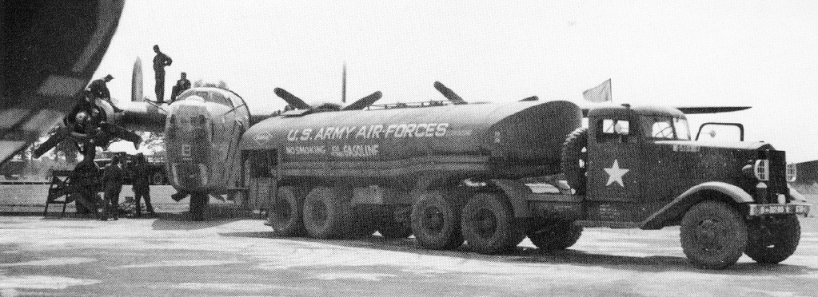

Fueling the aircraft with 2,750 gallons.
According to photo lab technician Harvey DeVoe, two to three lab personnel installed a camera in the floor hatch (between the waist area and the tail) of designated B-24s. They then attached trip wires to a bomb or bomb shackle. When activated, the camera took photos automatically at pre-set intervals until it ran out of film. The developed photos were used to analyze bomb strikes at the target and thus, mission effectiveness. An electric blanket covered the film section and camera mechanism to keep the camera from freezing up at altitude.

Air Crews
Lead crews were awakened first so they could attend pre-briefings. As they were briefed, CQs woke up the rest of the men. Officers and enlisted personnel were billeted separately but all were grouped by crew, so the CQ had only to call out a pilot's name to awaken the right men. They dressed, washed and shaved (to ensure a tight fit for their oxygen masks), and then went to breakfast, the cooks having been awakened even earlier.

Chaplains
Bert Prost was a gunner on the Wittel and Paroly crews in the 576th. He remembers, "Capt Paul A. McDonough (from Massachusetts) was our Group Catholic chaplain and a very good and dedicated man. On mission days we'd be awakened early, typically about 2:30 or 3:00am. We would proceed to the combat mess for a hearty breakfast. There at the rear of the Mess Hall were the Catholic and Protestant chaplains. Father Mac would give me Holy Communion and Conditional Absolution. The Protestant chaplain, Capt Donald B. Clark, could only shake hands and pray."

Briefings
The main briefing was attended by everyone in the selected crews. The "highlight" was when the mission map was revealed. 577th copilot Les Hadley recalls, "It was a real map; the route in and out was shown by colored tape pinned on the map. It was covered with a cloth that was drawn aside as the mission briefing commenced. The covering was withdrawn from west to east, so first we saw where our base was. Let me tell you, I and everyone held their breath as the curtain was withdrawn to the right, showing the continent and our route and the target area. As we flew more missions, we got to know where we would encounter the most flak enroute so we really looked at the map. Wish I had the ability to express our feelings at briefings...the Hollywood movies never came close."
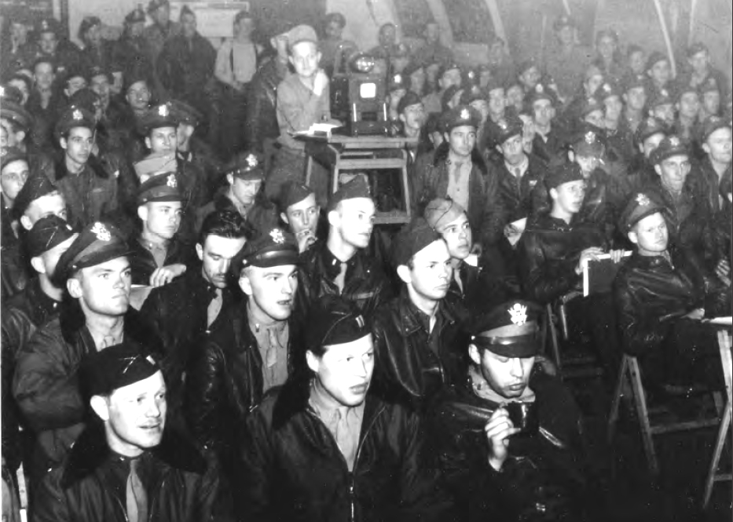

392nd crews being briefed for the first mission on D-Day. Front row, left to right: unknown, navigator Capt Leonard F. Untiedt, and navigator Capt Walter F. Joachim. Second row, left to right, pilot 1/Lt William Meighen, copilot 1/Lt John J. Mason, unknown. Behind Mason is navigator 2/Lt Thomas Kirkwood. Manning the projector is S/Sgt Harold Buirkle.
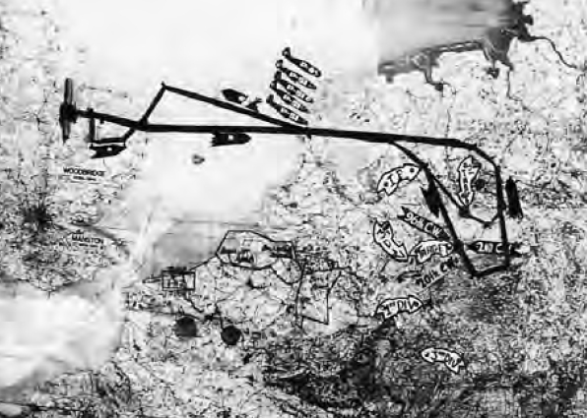

This is the map shown at the crew briefing on 28 Jan 1945. It shows where P-51 fighter escort was expected, the I.P. (Initial Point, at which the 392nd would turn toward Dortmund), targets for the 96th, 2nd and 20th CWs, and locations of the 1st and 3rd US Infantry Divisions.
Crews were told the location and importance of the primary and any secondary targets, camouflage in use, the route, check points, mission procedures, enemy defenses (both flak and fighters), and forecasted weather conditions. Emergency landing spots and POW and escape procedures were covered. As the war progressed, the current location of Allied and enemy troops on the ground was also given. The briefing ended with a "time hack" to synchronize watches.
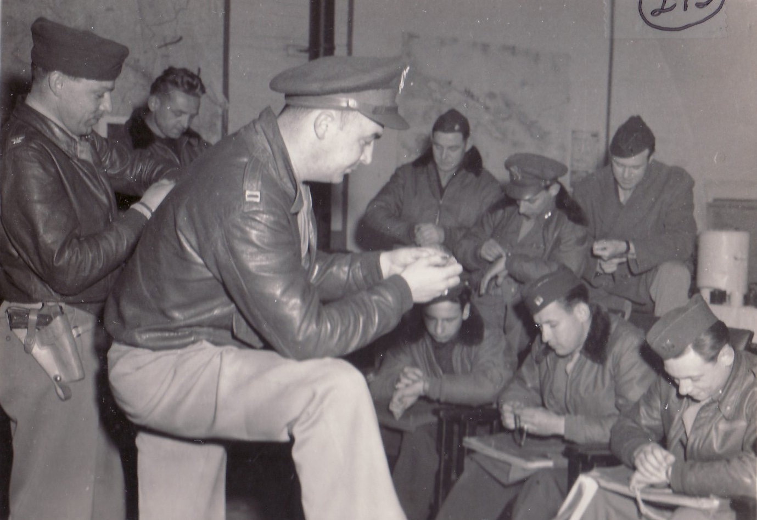

"Time hack" before the 392nd's 100th mission, the first of three on D-Day. At left with pistol is CO Col Irvine A. Rendle, in center is Group Bombardier Capt Harold Weiland.
Navigators and bombardiers then went to additional briefings. According to 579th lead navigator Manny Abrams, "There we did our map planning, circling flak installations along our route, and developing a flight plan in advance." Gunners had their own briefing, too. It covered the target and route; type of friendly fighter support with time and place to expect it; type of enemy fighters anticipated and where, as well as probable attack tactics; the formation setup; when to disperse chaff to confuse enemy flak radars and how much; and escape and evasion information.
Radio operators got specific signal details such as the day's wireless codes, radio call signs and frequencies.

Flying Equipment
As each briefing ended, the men went to the personal equipment room and collected their flying equipment. (Flak aprons and helmets were delivered to the hardstands). Escape kits with foreign money, maps, matches, chocolate, and other items useful in evasion were distributed.

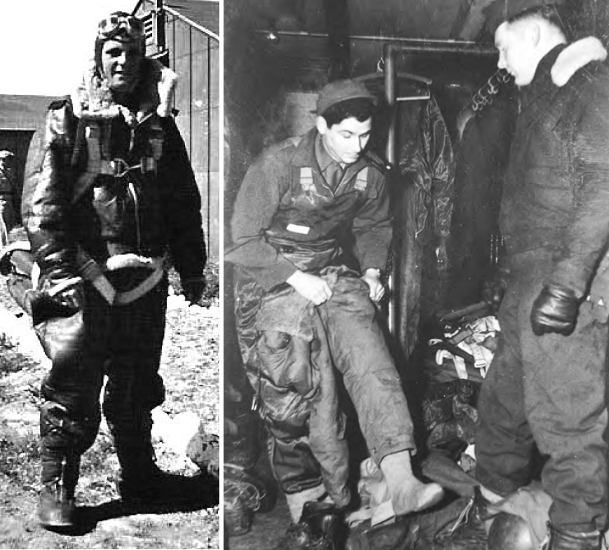

Left: Before the advent of the electrically heated flying suit, airmen used sheep skinlined clothes to combat the cold. Here, 579th radio operator T/Sgt William Sullivan on 1/Lt Gordon Hammond’s crew demonstrates his battle attire. A seattype parachute is attached to his harness.
Right: S/Sgt Jon Bross, on left, is putting an electrically heated flying suit over the heated boot inserts. The flying boots are in the foreground; parachute harnesses are in the background. At right, S/Sgt Perry Onstot is wearing the complete outfit.
Manny notes, "WWII was before the present day of pressurized or heated cabins. The air inside the plane was the same temperature as that outside. This required human adaptation to a harsh environment-frequently down to -40o C or lower. So, heavy underwear, heavy socks, regular uniform shirt and pants, heavy electric jacket and electric pants (a sturdy suit with copper heating wire running throughout), electric gloves, heavy shoes that fit inside sheepskin boots, a wool scarf and, of course, a parachute. As I recall, we would often have a chest pack 'chute as a back-up. "When aloft, add an oxygen mask, a flying helmet, goggles, and a flak jacket when needed. Finally (!) a steel GI helmet fitted on top of the flying helmet.
"I never weighed all of these articles of clothing, but I would estimate the total to be at least 40 pounds before flak helmet and jacket-round it all off at 75+ pounds. Standing for eight hours, the navigator could not think of feeling tired. At any moment, his information might become vital."

Transportation
When properly equipped, the airmen were taken to their planes.
Jim Goar was originally the 578th Sqdn Supply Officer. He says, "One of the early missions almost didn't get off the ground because the trucks weren't there to take crews to their aircraft. I was appointed Group Transportation Officer and I fully understood that I was to make sure it didn't happen again. I assigned a truck to two crews of the same squadron, and that truck was to be at the disposal of those two crews both for launch and recovery. Sometimes it took several trips to get everyone from Operations to the hardstands."
Jim also recalls that for safety reasons, Group Flight Surgeon Maj Robert M. Holland prohibited anyone from riding on truck tailgates. "I sometimes had to tell men going into combat that they couldn't sit on the tailgate because it was too dangerous."

At the Planes
Generally, waist gunners installed their guns and ground crew personnel installed turret guns. The pilot(s) and crew chiefs walked around the plane for a final visual inspection.
Parachute harnesses and Mae Wests were checked, chute packs and flak jackets placed at crew positions. Finally, the crew took their positions for take-off: navigator, bombardier and nose gunner usually on the flight deck; engineer between the pilots; radio operator at his desk; and the other gunners in the waist area.
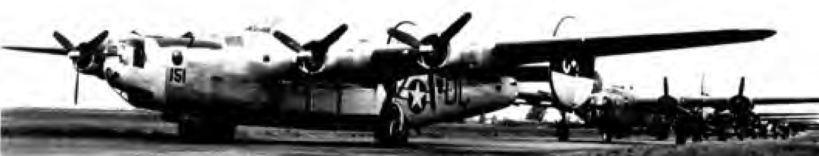

With 42-95151, Monotonous Maggie in front, B-24s on the taxiway wait for the go order. CO Col Lawrence Gilbert noted that when a mission was cancelled, the entire procession moved around the taxiway with pilots pulling off to their hardstands as they came to them. For some crews, this meant a slow trip around the entire airfield.

Taxi Time
The pilots started engines again. By this time, the Group Operations Officer was at the control tower. He would supervise the take off and handle any problems.
Flying Control fired a green flare as the sign to start taxiing. Each pilot knew his assigned place in the queue; the general order was lead, then high and low squadrons in the formation. In turn, each pilot signaled the ground crew to pull away the wheel chocks and then moved his ship onto the taxiway. Eventually, the Group and section lead planes stopped at the head of the runway, with a bomber's length between each plane lined up behind them. Depending on the number of planes, the entire taxiway could be filled. The noise of over 100 open-exhaust engines running and the frequent squeal of brakes was deafening. Each bomber used about 60 gallons of fuel during this period.

Launch
A green light, flashed from the checkered Flying Control trailer, was the go-ahead for take off. The lead pilot immediately released his brakes and headed down the runway while the copilot set all throttles for maximum power and the engineer monitored instruments. A fully-loaded B-24 needed about 3,000 feet to become airborne but common practice was to use the entire runway so as to gain maximum airspeed. (At Wendling, one runway was 6,000 feet long and two were 4,200 feet long.)

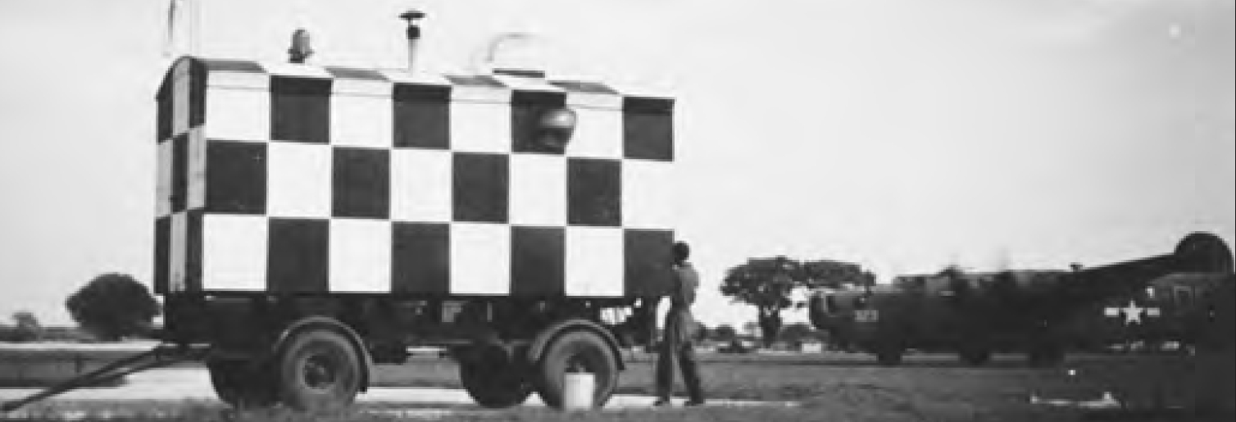

Men at the Flying Control trailer watch #42-50323, Heaven Can Wait, approach.
As one plane moved down the runway, the next a/c got into position; the engines were revved to full power with brakes applied. As the first plane lifted off, the control van signaled the second plane to move. Once in the air, each B-24 kept straight for about two minutes then headed to the Group assembly area, climbing at a predetermined rate.
To assemble with the correct Group, crews looked for their own Group assembly ship (a war-weary a/c painted in unmistakable colors) or for a plane shooting a specific color combination of flares.
Once fully assembled, the formation headed toward that day's target. Ground support personnel rested, for they would have work to do when the planes returned.

Getting Ready
576th Sqdn pilot William T. Kamenitsa wrote, “We called the cockpit The Front Office. Now, there are not many flight instruments in the cockpit—only the airspeed indicator, needle and ball, altimeter, and climb indicator. The rest are engine instruments. Before takeoff the copilot, pilot, and engineer coordinate everything. The pilot set all the throttles and fuel mixtures the same; the copilot checked the magnetos and energized the startup motor. This was a heavy duty thing that would rev up to high speed and then engage the engine. It would turn the props over like a starter on your car and it made that special high pitched whining sound as the engine engaged. It was the sound of World War Two for many of us.
“You’d taxi out for takeoff and you were ready to go to work.”

Assembly
After takeoff, a pilot usually kept on a straight course for about two minutes, in part because the B-24 was not very maneuverable until it had gained speed and altitude. The pilot then climbed at a predetermined rate (about 300 feet per minute at 150 mph Indicated Air Speed) to the assembly area assigned to the 392nd. A ship, usually #41-23689, Minerva, orbited a radio beacon at the prescribed altitude and fired designated colored flares to signal 392nd BG a/c. The specified assembly altitude was based on cloud conditions. Clear skies meant assembly could be at 5,000 to 10,000 feet. Often, though, pilots had to climb to 20,000 feet or higher to get above the clouds, relying on instruments to maintain headings, speeds and timed legs.
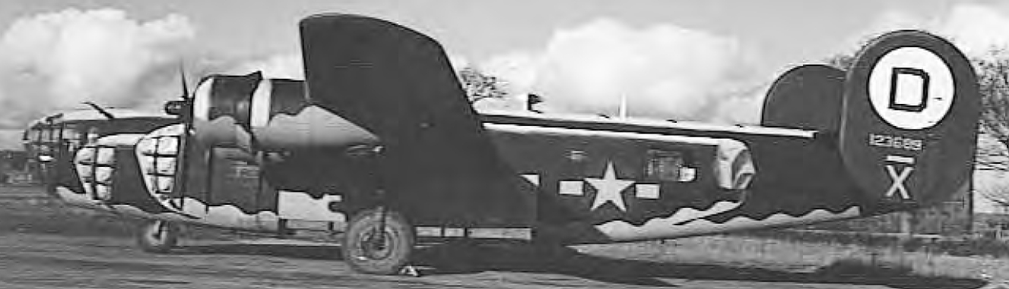

The 392nd’s assembly ship, #41-23689, Minerva
After finding the Group’s formation, 392nd pilots took their positions in the lead, high and low squadrons. Her job done, Minerva returned to Station 118 while the Group headed to the Wing assembly area.
Sometimes, a pilot was unable to locate his own Group. He then had to choose between two less than-ideal options: aborting or joining another Group on its way to an unknown target.
“Prior to D-Day,” 579th navigator R.W. “Red” Sprowls says, “we formed at higher altitudes in England in order to reach the European coastline near our target altitudes. This, of course, made us less vulnerable to 88s and 105 antiaircraft fire. After the invasion we formed at lower altitudes in England and generally had more time to climb to a bombing altitude while flying over occupied European territory.”
Hundreds of planes from bases all over England went through the assembly process almost simultaneously. Depending on the briefed altitude, weather conditions, and number of planes involved, assembly could take between 30 and 90 minutes. And, on every mission, there were pilots going through the process for just the first (or second, or third) time. To further compound the difficulty, 8AF planes often were forming up as RAF a/c were coming back from their night bombing missions.

Danger in English Skies During Asembly
Many airmen thought that assembly in English skies was almost the most dangerous part of a mission. After all, hundreds of planes fully loaded with bombs and fuel were being launched at the same time, in limited airspace, often in total darkness, with complete radio silence and no radar guidance from the ground. Statistics bear this out: 89 men who were or had been Crusaders were killed in action while forming up.
576th radio operator George Michel recalls that on one mission, “The gunners in the plane ahead of mine on the taxiway must have pulled the cotter pins from their bombs as it was easier to do on the ground than to squeeze back there with a walk-around bottle of oxygen and no parachute. Anyway, they crashed right after takeoff and the bombs exploded. My plane flew through the explosions. It was the worst flak I ever experienced.”
On 29 Jan 1944, 577th pilot 1/Lt William F. Usry collided at 14,000 feet with a plane from the 482nd BG flown by 1/Lt James N. Taylor. Aboard the 482nd BG a/c was Command Pilot Maj Clyde T. Gray, 576th Sqdn CO. Taylor and nine men in his crew had flown several missions with the 577th Sqdn before their transfer to the 482nd to be a Pathfinder crew. Everyone on Usry’s plane was killed, as were Gray and seven others in his ship (including six former Crusaders).
On 6 Mar 1944, 1/Lt Paul F. Shea, 579th, took off when fog limited visibility to 100 yards. His plane crashed and exploded about 2,000 yards from the end of the runway. The entire bomb load exploded and the a/c was completely burned. All 10 crew members were killed.
Assembly on 9 Apr 1944 was done under instrument conditions through a thick overcast. At about 7,000 feet, 578th pilot 2/Lt Hubert F. Morefield collided with a 389th BG plane. Eight men from the 392nd and nine from the 389th were killed.
Icing is the likely reason the left wing on 577th 2/Lt Louis F. Bass’s plane broke off during assembly on 21 Apr 1944. The plane crashed at North Tuddenham with eight men killed. The entire 8AF formation was eventually recalled, but not before two other B-24s also crashed in England. Maj Clinton P. Schoolmaster was the 577th Sqdn CO before being moved up to 14th Combat Wing Headquarters. On 25 May 1944, he was piloting a P-47 Thunderbolt and monitoring the form-up of the Wing's three Groups. When he didn't return, it was presumed he crashed at sea.
1/Lt Owen H. Filkel's crew (576th) was the first a/c to take off for Brunswick on 5 Aug 1944. Haze limited visibility to just 600 yards. The plane cleared the runway but crashed at 0925 hours near Sparrow Green, Gressenhall, killing the ten men aboard. The next plane in line took off 30 seconds later, flying directly through the smoke and flames.
A week later, 2/Lt John D. Ellis's plane (577th) was nearing London on its way to bomb an airfield east of Paris. Heavy overcast skies had already caused six 392nd planes to abort and put the sortie 30 minutes behind schedule. Contrails from Groups ahead merged into dense clouds. Ellis ran into "prop wash"-horizontal tornado-like turbulence caused by the clockwise rotation of hundreds of propellers-and flipped upside down. The a/c spun violently all the way down; the ten men were killed on impact near Cheshunt, Hertfordshire.
Capt James B. Stauder flew missions in the 578th from September 1943 to September 1944. In November 1944 he was sent on detached duty to the 2AD's Scouting Force, co-located with the 355th Fighter Group at Steeple Morden, Cambridgeshire. According to http://www.littlefriends. co.uk/gallery.php?Group=sf, the Scouting Force, flying P-51s, was tasked with "helping the Squadrons, Groups, Wings and Divisions to form up over England, leading the bomber stream through bad weather, appraising the mission commander of weather at the primary, secondary, & tertiary targets, helping tighten bomber formations, and defending the bomber stream against enemy fighters." While performing these duties during the mission to Bingen on 25 Nov 1944, Capt Stauder was lost at sea.
On 25 Mar 1945, the 392nd had just finished Group assembly and was moving to the Wing assembly area. After entering clouds at about 12,500 feet, 578th pilot 2/Lt Phillip W. Kaiser and 576th pilot 1/Lt Clifford O. Markuson collided. Sixteen men were killed.
The 14 Apr 1945 target was a gun emplacement north of Bordeaux, France. 2/Lt Charles W. Warner, 578th, had just cleared the runway when his two left engines lost power. The fully-loaded B-24 crashed at 0445 hours. The remaining planes took off over the burning wreckage. Seven crewmen were killed immediately; the eighth, nose gunner S/Sgt Donald A. Kight, died in a hospital on 29 May 1945. He was the last 392nd casualty of the war.

Ball Turret Gunners: An Elite Group
Ball turrets occupy a special place in aviation history. The B-24 and B-17 bombers are the only aircraft to have ball turrets. In the 392nd, their time in combat was limited to September 1943 through summer 1944.
Due to its low ground clearance, a B-24's ball turret (BT) was housed in the fuselage just aft of the waist guns during take off and landing. Once lowered into position below the plane, the ball turret could move in a complete circle horizontally and rotate 90 degrees downward. Its gunner fired on enemy a/c coming from any direction below.
As the plane flew toward enemy territory, the BT gunner used a hand crank to point the guns straight down, thereby making the hatch door accessible. Unfastening the hatch, the airman lowered the turret using a hydraulic valve. After disconnecting his oxygen hose, interphone and electrically heated flying suit, the gunner stepped down into the turret. He sat on a metal shelf; the door served as his back rest. There may have been a clip-on safety strap but certainly no elaborate mechanism to keep the gunner from falling if his turret were damaged.
Once inside, the gunner refastened his cords, latched the door and turned on the hydraulic and electric drive motors. After charging the two .50-caliber machine guns by pulling handles located at his feet, he was ready for action. Until the ship was out of enemy range on the return trip, he'd be on his back, feet straddling the 18-inch viewing plate and knees bent in a fetal position. To fire below the plane, he had to rotate the turret until he was positioned nearly upright. Thumb buttons fired the guns and moved the turret. The intercom talk switch was under his right toe; beneath his left heel was the spring-loaded range pedal for the Sperry computing gunsight.
The guns and ammo cans left little space for the airman and no room at all for his parachute. The cans held 1,150 bullets total, enough for 90 seconds of constant firing. (That would burn out the gun barrels, though, so gunners fired only in very short bursts no matter how intense the combat.)
The gunsight was mounted in front of the gunner's face. A mechanical analog computer, it was sophisticated for its time. The gunner tracked an attacking a/c in azimuth and elevation and raised the range pedal as the enemy fighter closed in. The gunsight advised when the target was at a firing range of 1,000 yards. The sight automatically led the target and compensated for bullet drop over distance.
A 2AD memo to 8AF dated 21 May 1944 recommended removing ball turrets from its B-24s. "Operational experience" suggested that "the benefit derived from the Sperry ball turret may not be commensurate with the weight and parasite drag involved in this installation."
As proof, 2AD gave statistics showing that ball turrets accounted for only 5.1 percent of 1,022 gunner encounters with enemy a/c between November 1943 and April 1944. The tail turret was highest, at 30.5 percent, followed by top turret (17.2 percent), nose turret (16 percent), and waist guns (15.6 percent each). Additionally, the ball turret position had the smallest number of claims approved as destroyed (3 percent), probably destroyed (4.4 percent), or damaged (4.4 percent).
2AD said the small number of claims by BT gunners did not justify the extra gas consumption caused by the 1,500 pound turret. 2AD also reported that of its 14 Group commanders, five wanted to remove all ball turrets, two wanted to remove them from some planes, and seven did not want to remove them yet but might want to do so at a later date.
2AD suggested the ball turrets be stored at each Group in case they were needed in the future. 8AF gave its approval, but the date is not known. Bert Prost, 576th waist gunner, flew his last mission on 29 Jun 1944. He is positive the 392nd's ball turrets were still in use then.
465th Sub Depot Sheet metal workers in the 465th worked long hours to make covers to patch the holes and then to build wooden crates for storage and eventual shipment to the US. 576/9th pilot Don Scharf says, "The hole in the bottom of the plane was covered over with the regular aluminum skin and the hole in the waist section by corrugated aluminum flooring to match the flooring where the waist gunners stood."
The 465th history for August 1944 reports, "The tough problem of securing the lumber held up the packing and crating for some time but this month finds close teamwork between the boys in Sub Depot Supply and the Engineering Carpenter Shop. There are still a few more of these turrets to be packed but there is no particular hurry as the turrets have to be held here until the ship to which the turret is assigned either goes down in action, becomes salvageable or war weary, or is transferred to another station. The packing and crating of the turrets is not an easy job due to their shape and weight. Much credit is due both departments for this splendid and efficient teamwork, the same kind of teamwork that the paper headlines proclaim is being used by the Allied Armies in making a rat race out of the German forces in France.”
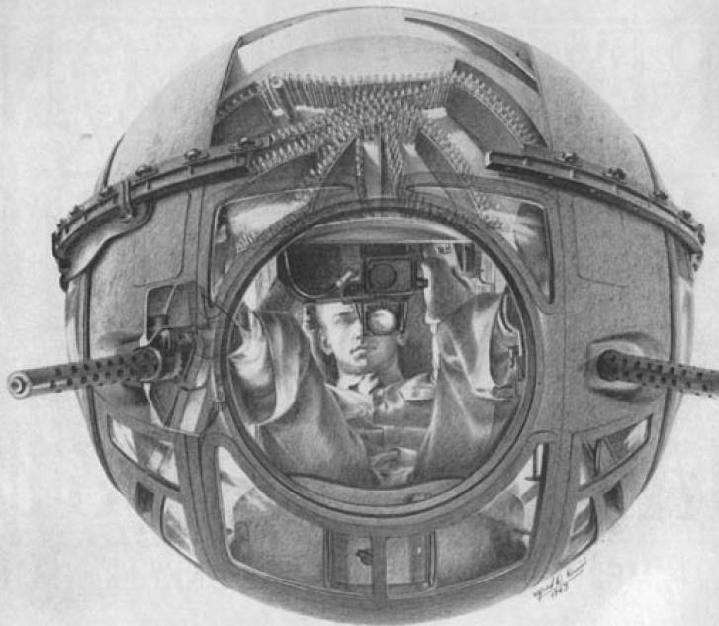

The Life magazine 29 Jan 1944 drawing shows a ball turret gunner in combat position.S/Sgt Zigmund T. Kaminski, 465th Sub Depot Supply Te c h n i c i a n , stands behind an upside down ball turret. The.50 caliber guns fit into the holes on either side of the observation window, whose Plexiglas was about two inches thick. The photo shows why the man in the ball turret was often the smallest gunner on his crew.

Although the ball turret seems the most dangerous crew position, statistics show it was the safest. The Office of the Chief Surgeon, European Theater, analyzed 8AF battle casualties between June and August 1944. Of 1,117 casualties due to missiles, 20.9 percent were waist gunners, 17.6 percent were bombardiers, and 12.5 percent were tail gunners. Only 5.9 percent were ball turret gunners.
What happened to the 392nd’s BT gunners after their turrets were removed? In many cases, the man was taken off his own crew to become a permanent substitute, filling in on any crew that needed a gunner due to injury or illness. Other crews apparently rotated their four gunners through the three guns in the waist and tail. Still others used the BT gunner in the nose turret where previously the bombardier had manned the guns. Eventually, crews ordered to the 392nd did not include a ball turret gunner.
Of 963 casualties from flak, 21.6 percent were waist gunners, 15.8 percent were bombardiers, 13.2 percent were navigators, and 12.6 were tail gunners. Only 5.5 percent of flak casualties were ball turret gunners.
These statistics are somewhat skewed because each plane carried two waist gunners. Also, by the time of this analysis, the ball turrets had been removed from some or most B-24s so BT statistics were mainly for B-17s.

Groups -> Wings -> Divisions
After each Group assembled, they formed into Wings and then Divisions. It was critical that each Group and Wing get to their assembly points at the specified time and altitude in order to take their designated position in the bomber stream. To help, assembly routes included dog legs, or L-shaped course changes. If a Group or Wing was behind schedule, it could cut across the dog leg to make up time. If it was early, the planes flew in circles or in an ¡§S¡¨ pattern to kill time. As the formation grew, it became more cumbersome to maneuver and harder for late planes or Groups to merge in.
Once the planes were aloft, airmen moved to their assigned positions. In some crews, it was routine practice for the tail gunner to be in his turret throughout taxi, takeoff and assembly so he could watch for planes coming too close. The ball turret gunner did not usually enter his turret until the plane neared the reach of enemy fighters.
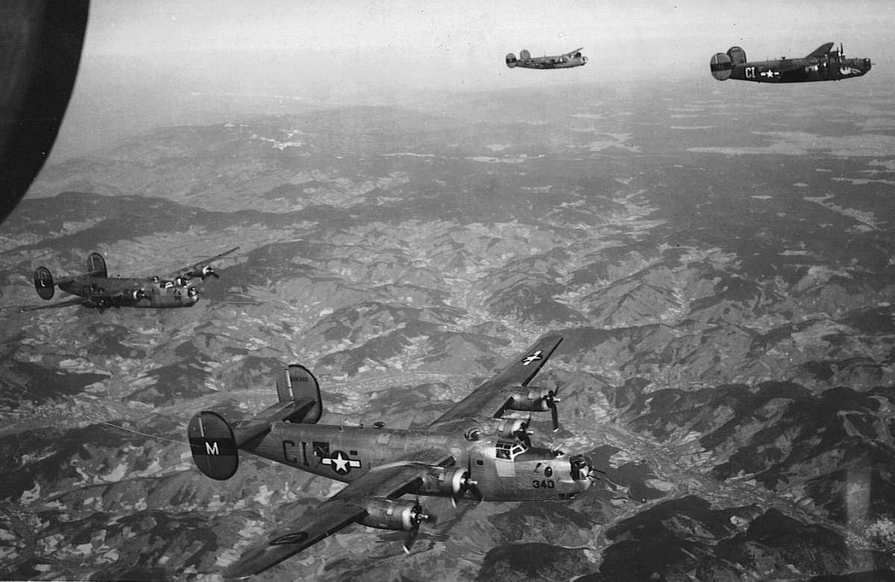

The 576th Sqdn during the 22 Mar 1945 mission to the jet airfield east of Schwabisch Hall. Clockwise from upper right: 41-29476, Gashouse Gus, with pilot 1/Lt Frederick T. DePalma; 42-51340, with pilot 2/Lt William Raczko; 41-28991, Gravel Gripper, with pilot 2/Lt Donald E. Ault, and 42-95299, with pilot 2/Lt Herchel E. Proctor.

In Flight
As the plane climbed, the temperature dropped. There was no central heating or air conditioning; the temperature inside the plane was about the same as the temperature outside. Waist gunners stood in front of open windows for hours on end. Wally Blackburn, 579/6, served as both a waist and tail gunner. He says it was colder in the tail than in the waist but it was coldest of all in the nose, where the crewmen suffered not only from the cold temperature but also from the wind roaring through the gap between the turret and fuselage. Electrically heated flying suits were therefore plugged in and rheostats adjusted to the desired warmth. When they worked, the suits were wonderful. There were many problems, though, especially for waist gunners. 576th gunner Bud Guillot on the Kamenitsa crew says, "Waist gunners were always kneeling and then standing up again, depending on where enemy fighters were and how they had to position their gun. As a result, the wires behind their knees would short out; sometimes they would burn the skin or catch fire." The suits didn't always heat evenly, with feet too cold and hands too hot, for example.
Radio operator Gerald Gersten, 577th, recalls a mission to the oil refineries at Harberg, Germany. Pilot 1/Lt Dale W. Enyart directed Gersten to open the bomb bay doors manually. He sprang into action so fast that his oxygen mask and interphone headset came off and the cord to his electrically heated flying suit detached. Engineer T/Sgt Charles E. Aycock came to the rescue and reconnected all his cords. However, Gersten had been unplugged long enough that he lost all the toenails on both feet.
The B-24 was not pressurized. 578/9th Sqdn radio operator Bert Hinckley recalled that for breakfast on the morning of a mission, "we had fresh eggs and any other breakfast foods that would not generate abdominal gas. Non-pressurized flying meant that gas would expand to triple volume, at altitude." Airmen were cautioned not to chew gum before or during high altitude flights as too much air was swallowed in the process which could lead to potential problems.
"The only protection the plane offered was the 1/8th inch aluminum skin," he said. "The only armor-plating was steel around the back and sides of the pilot and copilot. Everyone else had to depend on the flak vests and helmets."
Pilots sat on their parachutes; all other airmen generally used chest-type parachutes. Most turret gunners couldn't fit in their turrets if they wore a chute; men who could wear a parachute usually didn't as they were bulky and the added weight was exhausting. Therefore, airmen often left their parachute packs on the floor near their position with the hope that they could find them and have time to hook on a chute if necessary.
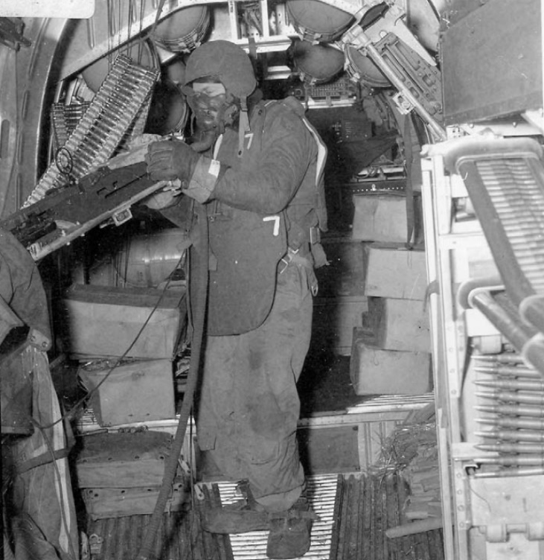
This photo, looking toward the front of the plane, shows 579th ball turret gunner S/Sgt Richard Hoffman during a combat mission. Before takeoff, waist gunner Sgt Charles D. Martin was given a camera and told to get some combat photos. After Hoffman’s turret was damaged by an ME-109, he went up to the waist area. Hoffman saw more ME-109s coming in with machine guns firing. He grabbed Martin’s waist gun and was shooting back when Martin took this photo. Hoffman is wearing complete combat gear, including a flak vest (7.5 pounds) and flak helmet. The thick hose connects his oxygen mask to the onboard system (the oxygen came from the large tanks overhead). Two parachute packs are at his right foot. Parachute packs were bulky and cumbersome so about half the men who could wear chutes didn’t; instead, they placed them near their stations to grab in an emergency, as Hoffman did. The thin cords connect him to the interphone (the on-board communication system) and an outlet for his electrically heated flying suit. The boxes in the background are probably filled with chaff. The machine gun belts for the waist gunners are visible on both sides of the photo. Even with their thick gloves, a gunner could hook on another belt in less than two seconds. The lens used to take this photo distorts the dimensions; it is not quite this crowded in the waist section!

Oxygen

All crewmen were required to go on oxygen as the plane gained altitude. 579th navigator Red Sprowls recalls, "We generally were instructed to use oxygen around 8,000 feet. If it was a long mission we might delay using oxygen at this altitude in order to conserve the supply. Oxygen was also used to overcome the effects of too much celebrating the night before and it was not uncommon to don the oxygen mask even prior to takeoff."
A designated man made an "oxygen check" every 15 minutes. 578th tail gunner Joe McNiel says every person in his crew had a number, which they repeated during the check. If a man didn't answer, someone would go to his position to ensure he was ok.
Faulty oxygen equipment or a disconnected hose could cause death in minutes. For example, on the 2 Nov 1944 mission to the oil refinery at Castrop-Rauxel, 576th tail gunner S/Sgt Jack V. Negus was found unconscious, leaning out of his turret. He died soon after. Official reports say he suffered a heart attack, but navigator 1/Lt James McCutcheon's log noted that he died of anoxia, or lack of oxygen in the blood. 576th tail gunner John Rosenberg says his "first mission could have been his last if it weren't for the oxygen check." On 4 Dec 1944, he was having trouble with his turret guns. As he tried to fix the problem, he dislodged his oxygen connection.
When he didn't respond to the next check, waist gunner S/Sgt Robert W. Brennan came back and revived him. "It was like being suddenly awakened from a very deep sleep," Rosenberg says. "I was startled, so I punched him!"
If the mask didn't seal tightly, ice crystals formed on the face as the airman's breath froze. Blackburn says after flying four missions in four days, his face was extremely chapped and "Vaseline was the only remedy." 577th tail gunner Harry Walz comments that even something as simple as not shaving properly before a mission could keep the mask from fitting close enough.
Guillot recalls, "Lark Morgan, our tail gunner, smoked with his oxygen mask on. He would move the mask to one side of his face and stick a cigarette in the corner of his mouth and then pull a little of the mask over the lip holding the cigarette. One could easily judge the ferocity of each mission by the number of cigarette butts on the floor of Morgan's tail turret." If a man had to leave his position for any reason, he unplugged the hose and attached a small "walk-around" bottle that held about 15 minutes of oxygen. They were also used in other emergencies. 579th pilot 1/Lt Harrison Cassell wrote his wife about the mission on 13 Nov 1943, "Just after we had hit the target (Bremen, one of the toughest in Germany) fighters were coming in from all directions and the top turret was busy spinning around tracking them. We had an oxygen filler hose connected to it & while spinning it came off-and before the radio man could get it stopped the oxygen all ran out of the system that supplies the nose. The nose turret gunner passed out. Then [bombardier William F. Cetin] passed out & [navigator Kenneth S. Bevan] called me about then. We kept passing around the walk-around bottles down to them and then they finally came to with Ken doctoring them."
In his journal, Cassell noted that right waist gunner S/Sgt Cecil Rothrock "passed out & was out for a good while. He also got his heel burnt and two toes frozen on the same foot."

Food and the Bathroom
In a June 2005 interview, 578th copilot William Riddleberger said, "We did not eat or drink or relieve ourselves during the entire flight. Prior to the mission, each of us was given a chocolate bar and a fruit bar, but we rarely ate it during the flight. I would leave them in my locker, and eat them later on." Gersten took a candy bar with him. It froze at altitude but he still gnawed on it when he got hungry. "After all," he says, "I was young and invincible."
If someone had to go to the bathroom in flight, there was a relief tube in the plane, basically a funnel that opened outside the plane. Memories differ as to where it was located. Blackburn's ground crew chief always put empty ammunition cans throughout the plane. If one was used during the flight, the airmen tossed it out over the water on their way back so the ground crew wouldn't have to deal with it. Flak helmets could also be used if necessary.
Most airmen simply didn't think of eating or using the bathroom during a mission as they were too focused on fighters and flak.

Interphone
A B-24 was so noisy that communication was only possible through the interphone. It was an open circuit so everyone heard everything that was said. The navigator regularly informed the pilots of times and headings. When under attack, gunners advised each other of incoming enemy a/c (i.e., "two o'clock low, twelve o'clock high").
When a plane got hit by flak or fighter bullets, the interphone system sometimes stopped working; as a result, men positioned far from the damage were sometimes not aware that their plane was in serious trouble till they saw flames and smoke in the a/c or parachutes blossoming below.

Arming the Bombs
As the first step in the arming process, a man had to go to the bomb bays and remove the safety cotter pins from the bombs. As the armorer-gunner on his crew, Guillot "was responsible to remove all the safety pins and serial number tags from each bomb in our bomb bays as soon as we got over the English Channel. The safety pins were there to keep the bombs from exploding if they were accidentally dropped on takeoff or on the English Countryside. I had to save each of those tags to turn in after each mission to prove the bombs were armed and ready to detonate on ground contact. I was to hook into the portable oxygen bottle, go through the small door to the bomb bay with my bulky flight suit and chest parachute harness on and walk down that narrow catwalk between the two bomb racks carrying that awkward portable oxygen bottle, wind whistling through the loose-fitting, noisy, rattling bomb bay doors while retrieving all bomb tags. I never attempted making that walk again with a portable oxygen bottle. I just held my breath."

Test-Firing the Guns
At about 25 miles out from the English coast, gunners fired a short burst to ensure their guns were working correctly. Even this simple, routine task could have unexpected results. While at 19,700 feet on 29 Apr 1944, 579th pilot 2/Lt Dewey L. Gann noticed a large oil leak in the #3 engine. He feathered the prop and aborted. Inspection on the ground revealed that an empty shell case, ejected when ships in front of him test-fired their guns, had severed the oil line.

Radio Operator/Engineer Duties
Radio silence was generally maintained, but radio operators always manned their sets, listening for Morse code messages affecting recall, diversion or change of target. 577th Sqdn engineer Gerald Cross says one of his main duties was to "transfer the gas as needs be and situations permitted-during a lull in the action, never during fighter attack or warning. Some planes were more gas efficient, so were some pilots. The position in the formation had a lot to do with throttle jockeying and increased gas consumption." Joe DeSario, 579th engineer, said he usually transferred fuel after leaving the target. With the sight gauges as a reference, he moved gas between the tanks so that each engine had the same amount of fuel.

Chaff
When the formation neared known flak zones, waist gunners were instructed to throw chaff out of the plane. These strips of aluminum were intended to mislead German flak radars about the formation's altitude.

Gunners
An air-cooled Browning .50 caliber machine gun fired 750 to 850 bullets per minute at a velocity of 2,900 feet per second. Gunners fired only in short bursts so the gun barrel wouldn't overheat. Gunners constantly scanned the skies for enemy fighters, often staring into the morning sun in the process. DeSario says they had sunglasses "but they weren't the best in the world." Cross remembers that "watching the skies for those rapidly growing black spots demanded constant attention. Once when the contrails were very dense, suddenly out of the trails popped the nose of a German fighter plane, the 20mm guns blinking red fire. He had come in too close for anyone to react with control. The German pilot was experienced enough to drop down slightly and get out of the scope of the top turret. The tail gunner opened up but froze to his guns, burning one up completely. The nose gunner reported seeing white explosions up front. The shells went on each side of the top turret, except one which struck the #2 engine, knocking it out without exploding. The whole attack took only seconds. It took much longer than that for me to do several 'Our Fathers'."

Mission Routes
Routes were scheduled to avoid major flak areas as much as possible and to mislead enemy fighters about the intended target. Each route, then, included several course changes until the Initial Point (IP) was reached. The IP was usually an unmistakable landmark, both visually and on radar. At the IP, the lead plane alerted the formation to turn toward the target by signal flares or by opening its bomb bay doors. All other planes promptly opened their own bomb bays and made the turn while simultaneously aligning in trail. On the bomb run, Groups were usually two to five miles apart.

Flak
Riddleberger said, "With our air speed at about 300 mph during the bombing run, we were subject to anti-aircraft fire for about ten minutes. Most of the Germans were using 88mm anti-aircraft guns for flak fire. At the time, the German 88mm gun was considered the best anti-aircraft gun in the world. On the ground, the enemy anti-aircraft guns were usually protected by bunkers or revetments. Flak fire was encountered in areas other than over the target."
Almost every airman remembers missions when "flak was so thick you could walk on it." In his memoir, 578th pilot Bruce McClellan calmly notes, "At an average of 1,000 feet per second, it takes 20 seconds for an 88 shell to reach our altitude. In that same 20 seconds we shall have traveled something more than a mile. It's not exactly a turkey shoot for anti-aircraft guns."
He then writes, "First, we see the black puffs. Then we begin to smell the black powder. A little closer and we see the ugly red burst itself and perhaps feel and hear the impact of small shrapnel fragments. Those we can live with if we have just a bit of luck. When it's closer than that and shell bursts begin to toss the plane around, the odds are against us. We need lots of luck then.
"...as we approach a heavily defended area, the Germans employ the same sort of statistical analysis which we use to plot our course. Knowing from aerial reconnaissance the number and placement of enemy anti-aircraft batteries, we calculate a 'flak clock' which tells us how to select a route which reduces to a minimum the number of shells which can be flung at us while we are within range overhead. Conversely, the anti-aircraft defenders identify probable targets and calculate a mathematical 'box,' which they attempt to fill with enough shrapnel so that no plane, theoretically, can pass through the box without suffering fatal damage. None of us ever doubted that German calculations for 'boxes' over major targets were accurate. It was terrifyingly awesome to see ahead a 'box' of German anti-aircraft fire through which you knew you had to fly in your gossamer craft if you were to complete your mission."

Initial Point
When the planes got to the IP, they made the final turn toward the target. As McClellan points out, they were then "on a fixed track, which simplified the calculations of anti-aircraft batteries. We had no options of course or altitude. Whatever the target-railroad yard, engine factory, refinery-it was a fixed point on the surface of the earth, and we had to navigate to a fixed point 20,000 feet or so roughly above it to accomplish our mission."

Target
On the target run, lead bombardiers set their bombsights to allow for range (altitude) and deflection (bomb drift to the left or right as it fell to earth). The other bombardiers set up the assigned drop pattern on their intervalometers. This device controlled the time interval between successive bomb drops; the shorter the setting, the less distance between bomb hits on the ground as the plane flew over the target. Before the Radio Bomb Release, bombardiers pressed a toggle switch to release their bombs as soon as they saw bombs fall from the lead ship. The time lag between the first and later releases was accounted for by the bombsight.
The toggle switch could be used to bypass the bombsight in an emergency; there was also a manual release that jettisoned all the bombs at once. As the practice of dropping on the lead plane became the norm, many planes flew without an officer bombardier. The man who pushed the toggle switch was known as the "togglier."
After bomb drop, the lead plane continued straight ahead for a few seconds to allow trailing planes to drop their bombs and close the bomb bay doors. Then it made for the Rally Point. Chosen to be away from known flak batteries, the RP was where Groups reformed into defensive formations. As soon as possible, the radio operator in the Wing lead plane sent a "target bombed" signal to Division headquarters.

Hung-up Bombs
Occasionally, a bomb did not properly release from both ends of its shackle and was "hung up." This happened to 579th pilot Don Scharf's crew. He says, "After we had dropped our bombs on one mission, a live 500-pound bomb was discovered hanging at an angle from one shackle in the bomb bay. We couldn't land with a hung-up bomb as it might break loose when the plane touched down on the runway. When we got to a low enough altitude over the Channel, we opened the bomb bay doors and armorer/waist gunner Constantine Rigas had to walk out on the 10-inch wide catwalk without a parachute and try to pry the bomb loose from the shackle with a screwdriver. After much prying, in the frigid wind blast, he finally managed to get the bomb to fall away. Everyone breathed a big sigh of relief." [Editor's note: These incidents did not always end so well. On 13 Feb 1944, 579th gunner S/Sgt William G. Dickison fell to his death in the Channel while trying to release a hung-up bomb. His body was never recovered.]

Bailing Out
Guillot was told in training that "if it were necessary to bail out at extreme altitude, don't waste time looking for a portable oxygen bottle; just bail out and don't pull your ripcord. You may pass out for a couple of minutes but you will come to and have ample time to pull your ripcord and make a safe landing."
Riddleberger concurs. "Above 20,000 feet, the temperature was usually minus 40 degrees inside the plane. Without gloves your hands would freeze to the guns or metal. If you had to parachute from 20,000 feet, you were instructed to free fall for a while so you didn't freeze to death when you opened your chute." [Editor's note: Current US Air Force reservist Ben Jones says that WWII airmen did not have oxygen bottles to use as they descended. "The amount of time from bailout to landing was fairly short; that's why a lot of times you'll hear the stories of guys blacking out just after leaving the airplane and then coming to on the way down. There are various formulas about how fast you fall; on average it's about 30 feet a second but when the chute deploys that drops to around 10-15 feet per second (on today's chutes). So a freefall would be about 5.5 minutes from 20,000 feet to 10,000 feet" when you would no longer need oxygen.]

Return to England
With bombs gone and less fuel, planes flew faster on the return trip. After leaving hostile airspace, the bomber stream separated into Divisions, each with its own briefed landfall point. When 100 miles from England, badly damaged a/c began to divert to the nearest air base or the emergency landing fields at Manston or Woodbridge. Their landing strips were 1,000 feet wide and 12,000 feet long, perfect for planes whose hydraulics had been shot out or had other mechanical damage.
All planes began "letting down"-reducing altitude about 500 feet per minute-so they were down to just a few thousand feet by the time they reached the English coast. At that point, each Group made for its own station. Gunners couldn't completely relax until their plane landed, as on several occasions enemy fighters followed the bomber stream back to England and strafed some airfields.

top.

Wendling
The bases obtained an estimated return time when Flying Control picked up radio chatter. Operations was notified at once and the duty Ops Officer went to the control tower. The Ops clerk alerted all necessary sections, MPs were posted at the briefing room, and medical and fire department personnel went to their vehicles.
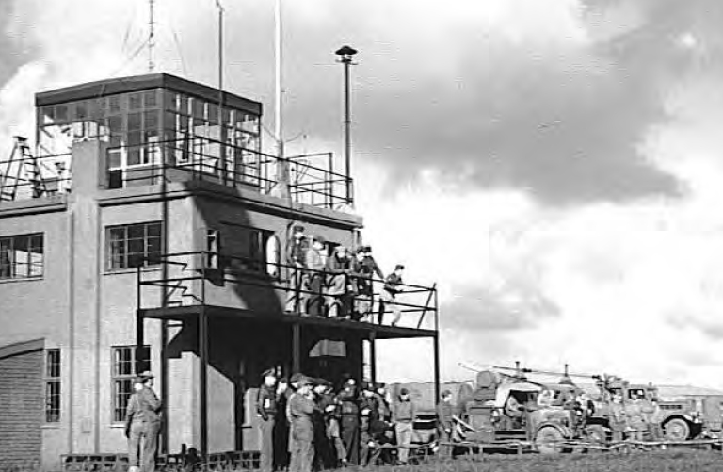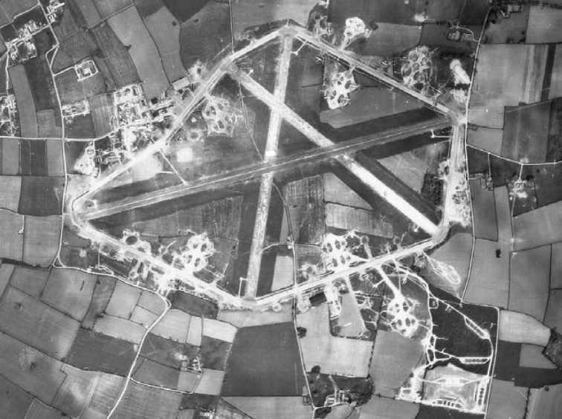

Many people gathered at the Control Tower to wait for the planes. This photo taken at 8,000 feet on 20 Apr 1945.
By this time, the formation was down to a few hundred feet. While in the landing pattern circuit, the engineer confirmed the wheels were down and locked. Planes with wounded aboard or severe battle damage fired two red flares and landed first. Otherwise, the left aircraft of the lowest left element of the low squadron peeled off to land first, followed by the element leader and the third a/c. These planes were followed by the second lowest element. Meanwhile, the lead and high squadrons made a wide left-hand circle above the base until it was their turn.
Scharf recalls, "There would be three or more planes on the runway at the same time: one ready to turn off onto the perimeter strip, one or two spaced on the runway behind him, and one just touching down. It was a hairy thing to do because if we misjudged our spacing we would run up on the guy ahead of us and would have to pour on full power, jump over him, and go around again. More than once I had guys run up on me and then thunder a few feet over the top of our plane. It was very disconcerting since I couldn't see them coming up behind me at over 100 miles per hour."
"Sometimes," Scharf continues, "badly damaged planes that were still in no immediate danger would circle until the rest of the group had landed to prevent blocking the runway in case they crashed on landing." This procedure sometimes had deadly consequences. On 29 Apr 1944, for example, plane #41-29427 exploded while in a landing pattern circuit over Wendling. 2/Lt Bernard Fryman and the other nine men in his 579th crew were killed.
Planes with wounded personnel turned off the runway as soon as possible, halting on the taxiway or the nearest hardstand where the ambulance was waiting. The other Libs went directly to their dispersal points, having opened their bomb bay doors to vent built-up gas fumes. DeSario says he often felt like kissing the ground and thanking God he had gotten back safely.

After Landing
After landing, crewmen deplaned and took off their flight gear at the hardstands. Gunners removed their weapons from the a/c; they were usually cleaned after interrogation. Engineers and pilots reported known mechanical problems and battle damage on Form 1A while other air and ground personnel made a visual inspection for additional damage. Logs maintained by S27, German Voice Interpreters, were picked up at the hardstands for immediate transfer to 2AD. Photo lab technicians removed cameras from planes and began developing the film right away.

Interrogation
Trucks took the men to the briefing room, which was now set up for interrogation. Every crew was checked in by an S-2 clerk who verified each man's name and position. Any changes from the original crew load lists were reported on a "Sortie Record" to ensure that everyone got credit for completing the mission. This report also named crews who would not get credit because they aborted.
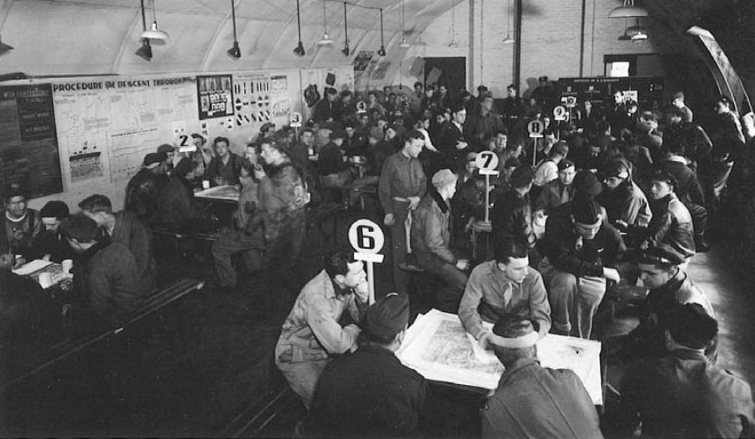

Crews are interrogated on 16 Jul 1944 after their return from Saarbrucken.
Personal equipment (parachutes, flying suits, Mae Wests, escape kits and oxygen masks) was turned in, as were bombardier and navigator folders. Then, the exhausted airmen got refreshments, served by Red Cross personnel. Coffee, juice, donuts, sandwiches, and a shot of whiskey were available. Engineer Gerald Cross notes that the 577th Sqdn greeted its returning crews with 100 proof Pennsylvania bourbon served in glass tumblers. In his memoir, Country Boy, Combat Bomber Pilot, Robert H. Tays, 578th, recalled, "After each mission, we were served a double shot of straight bourbon for medicinal purposes. Not having eaten since early in the morning and with empty stomachs, the effect was quite pronounced."
Aircrews first reported "hot news"-details on convoys, a/c in distress, etc.-that needed to be transmitted right away. Crews were then thoroughly questioned. Using a preprinted Interrogation Form, the debriefing officer noted crew comments about their bombing attack (time, altitude, heading, number of bombs dropped on target or jettisoned, and results, if seen); personnel injuries and plane damage; equipment malfunctions or failures; enemy a/c encounters (including tactics and unusual weapons used); friendly fighter support (time, place and effectiveness); and locations and types of flak encountered.
579th navigator Red Sprowls notes, "It was always very important to know where and when the Group e n c o u n t e r e d flak since the Germans were using mobile guns mounted on rail cars and they continued to move their guns. We knew that the major cities were well-protected but intelligence always wanted the extent or any changes in the intensity of the flak. This was of course used in plotting the future route in and out of targets. These flak areas were plotted on the lead navigator and Mickey operators' maps and were extremely important if the Group was forced off the plotted course due to weather or error."
After all crews had been questioned, their responses were compiled and Missing Air Crew Reports (MACRs) drafted. Navigators turned in their logs and bombardiers completed bombing reports. Lead crew command pilots, navigators, and bombardiers wrote detailed accounts about what they did and why. If a tactical error had been made (such as bombing the wrong target), the process was especially intense. Finally, crews were released to go to the mess hall or to their barracks. For men who had just returned from a mission and knew they faced many more, sleep was difficult.
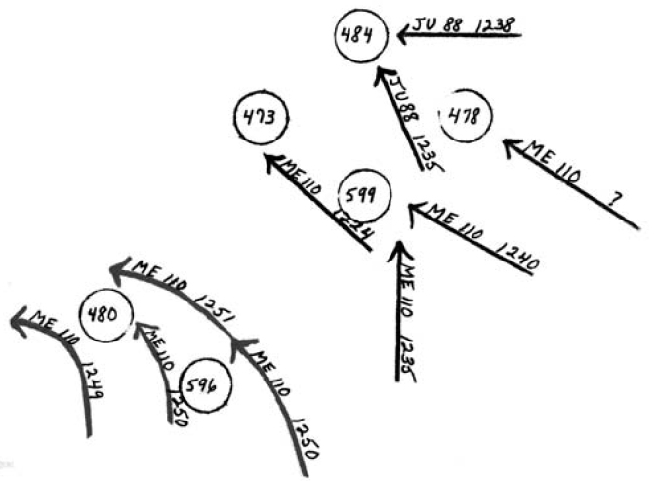
This Combat Duplication Check Form shows the time and type of enemy fighter attacks against the lead block (578 and 579th Sqdns) on 4 Jan 1944. Attacks portrayed on the upper right were from below; those at left were level.

Gunner Claims
A pre-printed Interrogation Form was used by S-2 officers to thoroughly document all claims by gunners that they had shot down an enemy a/c. It asked the tactics used by the enemy pilot, how close his plane came, what action the gunner took, where the enemy plane was hit, how much damage was seen, and how the plane looked and flew going away. Other crewmen who could verify the claim were named.
After all crews had been questioned, S-2 personnel created a Combat Duplication Check Form. Its diagram structure showed the direction, approximate time, and type of enemy a/c from all attacks; colored arrows showed whether the attacks came from above, below, or level. This visual aid helped S-2 officers determine if gunners were claiming credit for the same incident.
When all analysis was complete, the Interrogating Officer suggested the credit he thought the gunner deserved: no claim, damaged, probable, or destroyed. The claim forms were typed and submitted to 2AD where the final decision regarding approval and for what type credit was made.

Reports
Once the strike photos were developed, photo interpreters and intelligence personnel analyzed where the bombs impacted and likely damage caused. The information helped planners at 2AD and 8AF evaluate the mission's success.
A Telephone Flash Report (giving number of a/c airborne, dispatched, and attacking plus the number of a/c that did not bomb and why, personnel casualties, and number of planes with battle damage) was phoned to Division. Supporting details were sent by teletype to both Wing and Division as soon as possible. MACRs were finalized and submitted as was a detailed description of encounters with enemy aircraft and flak. Aircraft damage reports were prepared and photos taken.
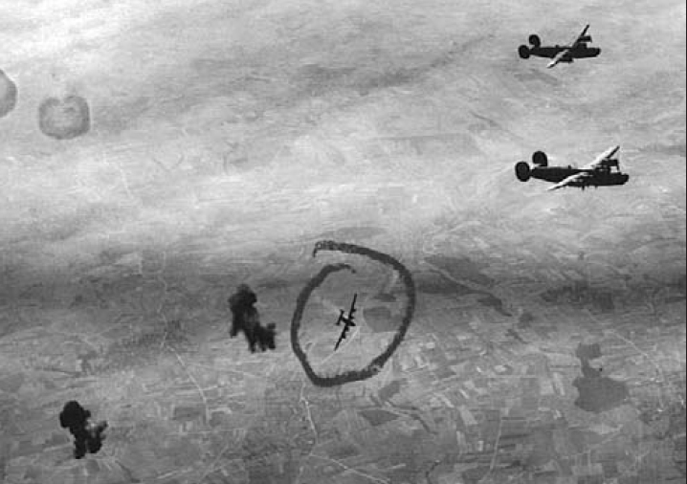
1/Lt Sidney Cohen’s crew, 578th, took this photo at 21,000 feet during the NoBall mission on 26 Mar 1944. The 392nd’s Photo Interpreter labeled it “B24 Down.” The photo may show 578th 1/Lt Robert E. Fletcher’s crew leaving the formation after flak killed bombardier 1/Lt Garland W. Judd and wounded tail gunner S/Sgt Joseph McNiel. Capt Edwin Reed was the 392nd’s Photo Interpreter until transferred to 2BD around May 1944; his replacement was T/Sgt Paul Wright.

S-2 personnel compiled the crews' reports and prepared a Formation Diagram at Assembly and Target and a list of turret and gun malfunctions for Group Operations. When all work was done, they returned target and map material to the S-2 Building.
1825th Ordnance Co. Commander Capt Jack Teufel reported the number of a/c departed, returned early, attacked target or were lost; the number of bombs loaded, expended on target, jettisoned, returned, or unaccounted for; the number of machine gun rounds expended by a/c that reached the target or aborted; and the quantity aboard a/c lost or missing.
The data reflected how bad the mission was. On 4 Jan 1944, the 23 Libs that reached the target expended 20,850 rounds against 50 attacking enemy a/c. On 13 Feb 1944, the 24 ships bombing the target fired only 2,332 rounds.

Ground Crews
After the planes were at their hardstands, maintenance crew personnel swarmed around their assigned Liberators to identify and start repair work. The line chief notified his squadron Engineering Officer of major problems and together they decided which planes could not fly the next mission.
579th turret mechanic Bernard Sender wrote, "You started working as soon as the planes landed. Air mechanics, armorers, and radiomen all headed out about the same time and assembled on 'The Line' to wait. When the crews and planes touched down, we'd go over and talk to the gunners to see what problems they'd had with equipment: Were the guns jamming? Did the turret motors behave properly? And so on. When the B-24s started coming over with the Emerson turrets in the nose, you'd talk to the guys up front-the bombardier and navigator.
"If it was three o'clock in the afternoon that the mission ended, you started immediately and worked right through the night. Let's say the dome on the top turret took some flak or it cracked... it had to be replaced. As winter drew near, the sun went down earlier. Let me tell you, it could be bitter cold at night over there, and we did all our work outside. You couldn't put spotlights up either, because they never knew when Jerry was coming around.
"We didn't work by the clock ... we didn't belong to a union, all right. When the task was completed, you'd go back to the barracks to get some sleep. That might not be until eight o'clock in the morning. If the mission was six hours, then we'd have to get back to the line when the planes returned that afternoon. To make things a little more efficient, they finally moved us to a farmhouse that was right on the line."

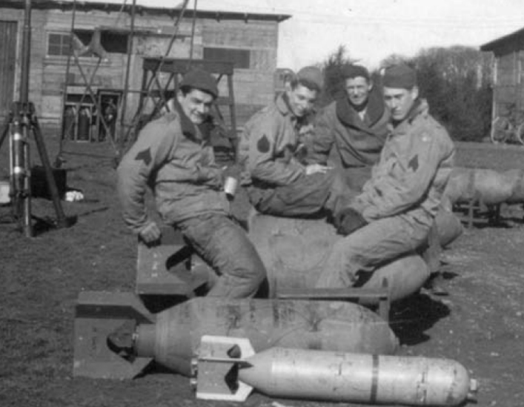
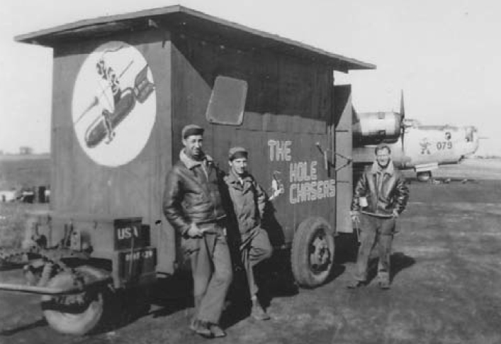
Pvt Rudy Santelli (2nd from left) and other 577th sheet metal workers with their repair shop, “The Hole Chasers”

L-R: 578th Power Turret Specialists S/Sgt John L. Kocevar, Sgt Kenneth W. Lintz, S/Sgt Hortis D. Hanna, and Airplane Armorer Cpl Andrew Pedeski wait for the planes to return.

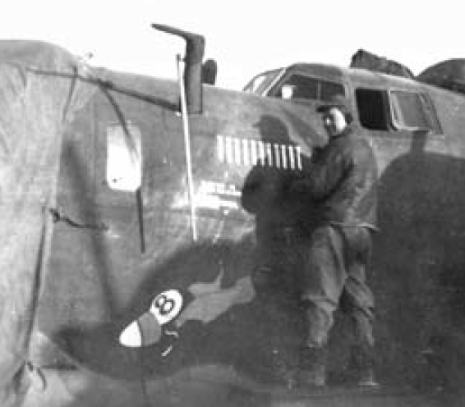
578th crew chief T/Sgt Lowell D. Hale paints bombs showing missions completed on #42-7624, Flying 8 Ball.

Many ground crewmen felt the Libs belonged to them and were only "loaned" to the air crews. And, although air and ground crews rarely mingled, there was a special bond between crew chief and pilot.
T/Sgt Lowell D. Hale kept #42-100187, Pallas Athene (The GI Jane) in great condition for 578th pilot Neely Young and crew. According to Neely, Hale "was the best crew chief in the 8th Air Force" and "he knew the plane from nose to tail." The last thing Neely always saw as he left his revetment was T/Sgt Hale giving him a thumbs up; he was always standing at the revetment when they returned. Neely says simply, "My crew and I owe our lives to him."
576th Inspector Stanley White noted, "The most forlorn [ground] crew could be found at the empty parking area of a plane that did not return."
He also wrote, "The mechanical work on the line was basically a remove-and-replace operation. There were a number of specialists available such as electricians, instrument repairmen, sheet metal workers, propeller specialists, and armament workers. Major repairs were performed at the 465th Sub Depot."
2nd Bomb Division and 8th Air Force
Intelligence Officers analyzed strike photos and teletype reports from all their Groups. Questions or requests for more data were relayed to the Groups. A preliminary assessment was sent to 8AF with updates as new information was received.
8AF compiled all the data to determine how effective the bombing had been and whether another attack would be necessary. Details on enemy defenses were used to update intelligence records. Analysis at the highest level continued even as the individual Groups and airmen were flying other missions.

The Weight of Command
Col Lawrence Gilbert, 392nd Operations Officer and eventually Commanding Officer, wrote, "We went over to England in 1943. I was a young 25-year-old with what might be considered a pretty heavy responsibility. At times I couldn't believe the decisions that were entrusted to me; then I'd look around at the upper echelon who were only a few years older than me. It was very sobering experience and it's very difficult to put into words what I felt when we lost crews. You didn't dare let it dwell in your mind for long; the chances are that by the time you found out you had lost six crews, you were well into planning for the next operation."

